
IP Communications Applications for Business Advantage

Metreos© Communications Environment 2.0 Metreos Management Console User Guide
Version 1

Copyright © 2005 Metreos Corporation
All Rights Reserved

Proprietary and Confidential Information

www.metreos.com | Part Number M-2400-UG-01
 | 5/2005

Information in this document is subject to change without notice.

Copyright © 2005 Metreos Corporation. All rights reserved. Metreos trademarks marked with a ® or © herein are registered or protected trademarks of Metreos in the U.S. and foreign countries. All other trademarks in the document are the property of their respective owners.
Table of Contents
Preface 4
Intended Audience 4
Information This Book Contains 4
Style and Formatting Conventions 5
License/Certification Information 6
1. Introduction 10
2. Metreos Application Runtime Environment 11
Provider Manager 12
Router 12
Telephony Manager 12
Application Manager 13
Management Interface 13
Application Runtime Environment 13
Logger 14
3. The Metreos Management Console 15
The Metreos Environment 16
Configuring the Console 16
Configuring Core Components 17
Configuring the Application Environment 17
Configuring the Application Runtime Environment 18
Configuring the Application Manager 18
Configuring the Logger 19
Configuring the Management Interface 20
Configuring the Provider Manager 20
Configuring the Router 21
Configuring the Telephony Manager 21
Managing Users 22
System Configuration and Control 24
Network Configuration 24
Service Control 26
Media Firmware License 26
System Update 27
System Backup and System Restore 29
Working with Components 35
Managing Applications 35
Managing Media Servers 41
Managing Providers 47
Provider Configuration Pages 48
Configuring CiscoDeviceListX 48
Configuring H323 49
Configuring the HTTP Provider 50
Configuring JTapiProvider 50
Configuring MediaControlProvider 52
Configuring Telephony Servers 53
Creating H.323 Call Route Groups and Gateways 54
Creating CTI Telephony Devices 56
Metreos Logs 64
Index 65

Preface
This document explains how to administer and maintain the Metreos Communications Environment (MCE) and applications developed for it.

Intended Audience
This book is intended for system administrators who are familiar with the Windows operating system and have a basic understanding of IP telephony.

This book does not provide information about IP telephony systems. For information about basic telephony and IP telephony we recommend the following Internet Web sites:

http://en.wikipedia.org/wiki/Voip
http://www.voip-info.org/tiki-index.php
http://www.packetizer.com/voip/

The MCE works with Cisco CallManager as a Voice over IP provider. You might therefore be called on to manage CallManager. The following sites provide useful information:

http://www.cisco.com/en/US/tech/tk652/tsd_technology_support_category_home.html
http://www.cisco.com/en/US/products/sw/voicesw/ps556/
http://www.cisco.com/en/US/products/sw/voicesw/

Information This Book Contains
The Metreos Communication Environment Management Console User Guide is organized into the following chapters:

- Chapter 1 Introduction – Provides basic information about the Metreos Communication Environment architecture.
- Chapter 2 Metreos Application Runtime Environment Overview – Describes the Metreos Application Runtime Environment and the components it comprises and manages.
- Chapter 3 Metreos Mangement Console – Describes the Metreos Management Console User Interface and provides administrative procedures for the Metreos Communication Environment

Style and Formatting Conventions
The following typographical components are used for defining special terms and command syntax:

Convention | Description
Bold typeface | Represents literal information such as  - Information and controls displayed on screen, including menu options, browser controls and field names  - Commands, file names, and directories  - In-line programming elements, such as class names and XML elements when referenced in the main text
Italic typeface | Italics typeface is used to denote  - A new concept  - A variable element such as filename.mca. In this example, filename represents the file name and .mca is the file extension.  - A reference to a chapter or section heading  - Emphasis
Sans serif typeface | Denotes code or code fragments
… (ellipsis) | Denotes omitted material
UPPERCASE | Denotes keys and keystroke combinations such as CTRL+ALT+DEL.
Table 1: Style and Formatting Conventions

License/Certification Information

Metreos Corporation

End User License

Important – Use of this Software is subject to license restrictions.
Carefully read this license agreement before using the software.

This End User License Agreement (the “Agreement”) is a legal agreement between you, either individually or as an authorized representative of the company or organization acquiring the license, and Metreos Corporation (“Metreos”). USE OF SOFTWARE INDICATES YOUR COMPLETE AND UNCONDITIONAL ACCEPTANCE OF THE TERMS AND CONDITIONS SET FORTH IN THIS AGREEMENT. If you do not agree to these terms and conditions, promptly return or, if electronically received, certify destruction of the Software and all accompanying items within five days after receipt of Software and you will receive a full refund of the applicable license fees paid.

1. License Grant

a. The software programs you are installing, downloading, or have acquired with this Agreement, including any related equipment or hardware, documentation, updates, upgrades, modifications, revisions, copies and design data (“Software”) are copyrighted, trade secret and confidential information of Metreos and its licensors who maintain exclusive title to all Software and retain all rights not expressly granted by this Agreement. Metreos grants to you, subject to payment of appropriate license fees, a non-exclusive, non-transferable, internal-use only, term license to use the Software owned or distributed by Metreos in machine readable, object-code form on the computer hardware or at the site(s) for which an applicable license fee has been paid, as authorized by Metreos.

b. To the extent that you design applications that operate on the Metreos Communications Environment (the “MCE”), Metreos grants you a non-exclusive, non-transferable, internal-use only, term license to use the Software, including the MCE, for the purposes of operating such programs, subject to payment of appropriate license fees.

c. The license granted herein is contingent on your (or your organization’s) continued acceptance and subscription to the maintenance and support terms provided by Metreos. Termination by you or your organization of ongoing maintenance and support requirements terminates the license granted herein.

2. Restrictions and Intellectual Property Ownership

a. You may not (i) remove or modify any notice of Metreos’ proprietary rights, (ii) re-license, rent, lease, timeshare, or act as a service bureau or provide subscription services for the Software, (iii) use the Software to provide third-party training, except for training agents and contractors authorized under this Agreement; (iv) assign this Agreement or give the Software or an interest in the Software to another individual or entity; (v) cause or permit reverse engineering or decompilation of the Software; (vi) disclose results of any Software benchwork tests without Metreos’ prior written consent; or (vii) modify the Software or any portions thereof without Metreos’ prior written consent.

b. The Software, which is copyrighted, and any modifications, upgrades, or updates thereto, is the sole and exclusive property of Metreos and is a valuable asset and trade secret of Metreos. Metreos retains all ownership and intellectual property rights to the Software and to any modifications, upgrades, or updates thereto. Except for the rights granted in herein above, you shall have no right, title, or interest of any kind in or to the Software.

c. Metreos may audit your use of the Software. If Metreos gives you or your organization reasonable advance written notice, you agree to cooperate with the audit, and to provide reasonable assistance and access to information. You agree to immediately remit any underpaid license and technical support fees determined as the result of such audit.

3. Term and Termination.

a. This Agreement remains effective until expiration or termination. This Agreement will immediately terminate upon notice if you exceed the scope of the license granted or otherwise fail to comply with the provisions in sections 1 and 2 above. For any other material breach of the Agreement, Metreos may terminate this Agreement if you are in breach and fail to cure the breach within thirty (30) days of written notification. If Software is provided for a limited term use, this Agreement will automatically expire at the end of the authorized term.

b. Upon termination of this Agreement for any reason, you shall within ten (10) business days return to Metreos all Software. Additionally, you agree to delete from any permanent machine storage (i.e., hard disk) previously loaded copies of the Software in all forms. Upon request of Metreos, you shall certify in writing that all copies of the Software and associated documentation have been destroyed or returned to Metreos. The indemnity and limitation of liability obligations hereunder, as well as your obligations with respect to confidential treatment of the Software and Metreos’ trade secrets, other intellectual property, and proprietary information, shall survive the termination of this Agreement.

4. Limited Warranty.

a. Metreos warrants that the Software will substantially operate as described in the applicable Software documentation for ninety (90) days after Metreos delivers it to you. THE WARRANTY HEREIN IS EXCLUSIVE AND IN LIEU OF ALL OTHER WARRANTIES, WHETHER EXPRESS OR IMPLIED, INCLUDING THE IMPLIED WARRANTIES OF MERCHANTABILITY AND FITNESS FOR A PARTICULAR PURPOSE. METREOS MAKES NO WARRANTY THAT ANY SOFTWARE WILL PERFORM ERROR-FREE OR UNINTERRUPTED, OR THAT ALL ERRORS THEREIN CAN OR WILL BE CORRECTED. METREOS FURTHER DISCLAIMS ANY IMPLIED WARRANTIES ARISING FROM COURSE OF PERFORMANCE, COURSE OF DEALING OR USAGE OF TRADE.

b. For any breach of the above warranty, Metreos’ entire liability and your exclusive remedy shall be, at Metreos’ option, either (1) refund of the fees paid upon return of the Software to Metreos, or (2) correction or replacement of the Software that does not meet this limited warranty, provided you have complied with the terms of this Agreement.

5. Indemnity

a. Metreos will defend and indemnify you against a claim that any Software, infringes a patent or copyright, provided that: (i) you notify Metreos in writing within thirty (30) days of the claim; (ii) Metreos has sole control of the defense and all related settlement negotiations; and (iii) you provide Metreos with the assistance, information, and authority reasonably necessary to perform the above; reasonable out-of-pocket expenses incurred by you in providing such assistance will be reimbursed by Metreos.
b. Metreos shall have no liability for any claim of infringement resulting from: (i) your use of a superseded or altered release of the Software if infringement would have been avoided by the use of a subsequent unaltered release of the Software which Metreos provides to you; or (ii) any information, design, specification, instruction, software, data, or material not furnished by Metreos or (iii) any combination of the Software with other hardware, software or processes that, but for the combination, the Software would not be infringing.
c. In the event that some or all of the Software is held or is believed by Metreos to infringe, Metreos shall have the option, at its expense: (i) to modify the Software to be non-infringing; or (ii) to obtain for you a license to continue using the Software. If it is not commercially feasible to perform either of the above options, then Metreos may require from you return of the infringing Software and all rights thereto. Upon return of the infringing Software to Metreos, you may terminate the Agreement with ten (10) days’ written notice and you shall be entitled to a pro-rata refund of the fees paid for the infringing Software. This subsection sets forth Metreos’ entire liability and exclusive remedy for infringement.
d. You will defend and indemnify Metreos and its licensors against any claim incurred by, borne by or asserted against Metreos or its licensors that relates to or results from (i) your use of the Software, (ii) any intentional or willful conduct or negligence by you or (iii) any breach of an applicable representation, covenant or warranty contained herein.
e. Should the party seeking indemnification (“Indemnitee”) reasonably determine that the party from whom indemnity is sought (“Indemnitor”) has failed to assume the defense of any claim referenced herein, Indemnitee shall have the right to assume such defense and have all expense and cost of the defense reimbursed by Indemnitor, including reasonable attorneys fees.

6. Confidentiality

The Software contains proprietary and confidential information of Metreos as well as trade secrets owned by Metreos. You agree to hold the Software in strict confidence and not to disclose the Software in any way except as expressly permitted hereunder. You agree to protect the Software at least to the same extent that you protect your similar confidential information, but in no event less than reasonable care. You further agree that you will not, directly or indirectly, copy the structure, sequence, or organization of the Software, nor will you copy any portion of the Software or related documentation to produce software programs that are substantially similar to the Software.

7. LIMITATION OF LIABILITY

EXCEPT WHERE THIS EXCLUSION OR RESTRICTION OF LIABILITY WOULD BE VOID OR INEFFECTIVE UNDER APPLICABLE LAW, IN NO EVENT WILL METREOS BE LIABLE FOR ANY INDIRECT, INCIDENTAL, SPECIAL, OR CONSEQUENTIAL DAMAGES, OR DAMAGES FOR LOSS OF PROFITS, REVENUE, DATA, OR USE, INCURRED BY YOU OR ANY THIRD PARTY, WHETHER IN AN ACTION IN CONTRACT OR TORT, EVEN IF METREOS OR ANY OTHER PERSON HAS BEEN ADVISED OF THE POSSIBILITY OF SUCH DAMAGES. METREOS’ LIABILITY FOR DAMAGES HEREUNDER SHALL IN NO EVENT EXCEED THE AMOUNT OF FEES PAID BY YOU FOR THE SOFTWARE OR SERVICE GIVING RISE TO THE CLAIM. IN THE CASE WHERE NO AMOUNT WAS PAID, METREOS SHALL HAVE NO LIABILITY FOR ANY DAMAGES WHATSOEVER.

8. Assignment; Jurisdiction.

This Agreement will be binding upon, and will inure to the benefit of, the permitted successors and assigns of each party hereto. You may not assign, delegate, transfer, or otherwise convey this Agreement, or any of its rights hereunder, to any entity without the prior written consent of Metreos, and any attempted assignment or delegation without such consent shall be void. This Agreement, and all matters arising out of or relating to this Agreement, shall be governed by the laws of the State of Texas, United States of America. Any legal action or proceeding relating to this Agreement shall be instituted in any state or federal court in Travis or Dallas County, Texas, United States of America. Metreos and you agree to submit to the jurisdiction of, and agree that venue is proper in, the aforesaid courts in any such legal action or proceeding.

9. Severability; Waiver

In the event any provision of this Agreement is held to be invalid or unenforceable, the remaining provisions of this Agreement will remain in full force. The waiver by either party of any default or breach of this Agreement shall not constitute a waiver of any other or subsequent default or breach. Except for actions for nonpayment or breach of either party’s intellectual property rights, no action, regardless of form, arising out of this Agreement may be brought by either party more than two years after the cause of action has accrued. The headings appearing in this Agreement are inserted for convenience only, and will not be used to define, limit or enlarge the scope of this Agreement or any of the obligations herein.

10. Restricted Rights Notice.

The Software is commercial in nature and developed solely at private expense. The Software is delivered as "Commercial Computer Software" as defined in DFARS 252.227-7014 (June 1995) or as a commercial item as defined in FAR 2.101(a) and as provided with only such rights as are provided in this Agreement, which is Metreos’ standard commercial license for the Software. Technical data is provided with limited rights only as provided in DFAR 252.227-7015 (Nov. 1995) or FAR 52.227-14 (June 1987), whichever is applicable.

11. Payment; Interpretation; Compliance.

You will pay all amounts invoiced, in the currency specified on the invoice, within 30 days from the date of such invoice. This Agreement constitutes the complete agreement between the Parties and supersedes all previous and contemporaneous agreements, proposals, or representations, written or oral, concerning the subject matter of this Agreement. This Agreement may not be modified or amended except in a writing signed by a you and Metreos; no other act, document, usage, or custom shall be deemed to amend or modify this Agreement. It is expressly agreed that the terms and conditions of this Agreement supersede the terms of any purchase order. Each party agrees to comply with all relevant export laws and regulations of the United States and the country or territory in which the Services are provided (“Export Laws”) to assure that neither any deliverable, if any, nor any direct product thereof is (a) exported, directly or indirectly, in violation of Export Laws or (b) intended to be used for any purposes prohibited by the Export Laws, including without limitation nuclear, chemical, or biological weapons proliferation. Each party agrees to comply with all federal, state and local laws and regulations applicable to this Agreement. Each party represents and warrants that it is qualified to do business in the geographies in which it will perform its obligations under this Agreement, and will obtain all necessary licenses and permits, and satisfy any other legal, regulatory and administrative requirements, necessary to its performance hereunder.

Introduction
The Metreos Communications Environment (MCE) is a feature-rich platform for developing and hosting IP telephony applications. The MCE includes an Application Runtime Environment controlling media and external resources under the direction of custom telephony applications. The Application Runtime Environment also works with one or more media servers to process, mix, analyze, and route digital audio data.

Applications hosted on the MCE are developed using a GUI-based design tool, the Metreos Visual Designer. Using the Visual Designer, you can easily create complex telephony applications. System administrators manage the MCE through a Web browser-based interface, the Management Console.

The following diagram presents a simplified view of the MCE Architecture:

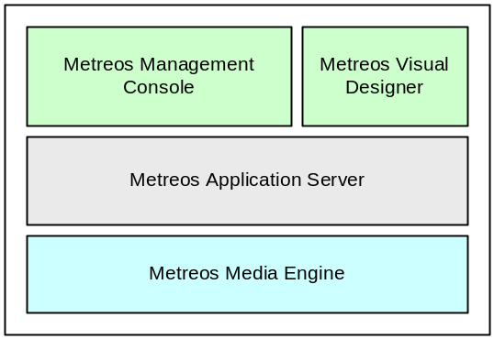
Figure 1: Metreos Communications Environment Architecture

Metreos Application Runtime Environment

The Metreos Management Console allows you to administer the Application Runtime Environment for IP telephony systems. The following diagram depicts the components of the server, their relationship to each other, and their relationship to other components in a telephony system:

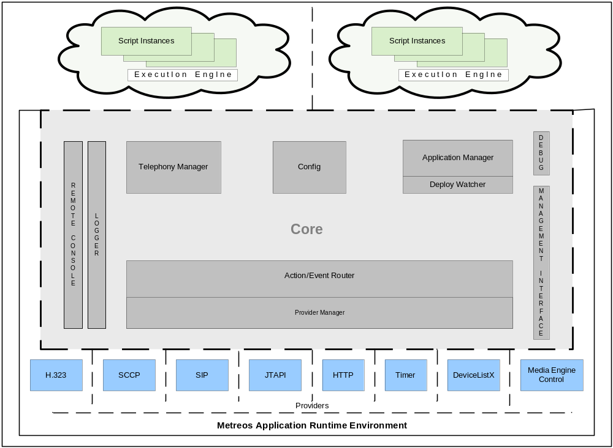Figure 2: Metreos Application Runtime Environment
The diagram depicts the applications and providers outside the core as separated by broken lines, which represent process boundaries. Isolating the processes prevents external components from affecting the system, in the unlikely event of failure.

You can access, manage, and configure the core components as well as applications and providers through the Management Console. Each core component manages some aspect of the IP telephony system, and the management console enables the configuration of those components.

The core components managed by the console include

- Application Runtime Environment – Manages the Metreos 2400 system—the engine used as a bootstrap loader for the other core elements
- Provider Manager – Manages loading and unloading of providers
- Router – Routes actions and events between providers and applications
- Telephony Manager – Manages the details of establishing and terminating a call
- Application Manager – Manages the installation and uninstallation of applications
- Management Interface – Notifies the core engine of changes to the Application Runtime Environment configuration
- Application Environment – A virtual machine providing a runtime environment in which IP telephony applications can be executed
- Logger – Manages log messages

Subsequent sections provide details about some of the core components.

Provider Manager
This component is responsible for instantiating and managing providers. Similar to a system process or daemon, a provider opens network ports and allows the Application Runtime Environment to communicate with other devices on a network.

These providers can be loaded or unloaded at any time through the management console. In addition to managing providers, the Provider Manager also manages basic administrative tasks. For example, it monitors providers to ensure they are running.

Router
In the Metreos system applications specify a set of triggering criteria. After an instance of an application is triggered, the Router retains the state of that instance and routes subsequent events until the instance terminates.

Telephony Manager
IP telephony applications require complex protocols to establish a connection between devices, exchange messages among them, and disconnect them when appropriate. This component abstracts implementation details so you need not be exposed to them.

As an administrator, the only Telephony Manager detail of which you need to be aware is the notion of sandboxing. Sandboxing is a system-level, failsafe capability ensuring system resources do not remain in use after a script ends.

If a script were to stop prematurely, it might not be able to terminate outstanding calls and the media resources for those calls would remain in use. In such an unlikely event, sandboxing would permit the Telephony Manager to release the media resources.

Sandboxing is globally disabled by default, but can be enabled on the Telephony Manager Configuration page. You should ensure sandboxing is disabled if you have an application in which control of the call is transferred from one script to another.

In such cases the media resources are retained after the original script instance terminates because the call is still in progress. The Telephony Manager then detects the original script has terminated and media has not been released. If sandboxing is enabled, the Telephony Manager would release the media on behalf of the original script and prematurely terminate the call.

Refer to Configuring the Telephony Manager for instructions on enabling and disabling sandboxing.

Application Manager
This component manages applications as they progress through the application lifecycle. Its primary responsibility is to unpackage applications and create the application runtime environment on their behalf. It also routes debugger commands to the appropriate application.

Using the Application Manager, you can install an application by uploading a Metreos installation package through the management console. The system automatically unpackages it and performs the installation process.

Each application instance has one or more partitions associated with it. A partition comprises a set of configuration data applied to an application. All application-defined configuration information and required call control and media resource settings are contained in the application partition.

A partition is a template that determines the behavior of an application,; it specifies parameter values such as triggering criteria. The MCE supports multiple partitions for each application, each of which can specify different triggering criteria and other parameter values. When multiple partitions are defined, multiple user groups can execute concurrent instances of a given application, each running in a uniquely-configured partition.

When an application is installed a default partition is created, which the application uses if multiple partitions are not required. Refer to Managing Applications for instructions on creating and editing application partitions.

Management Interface
This component listens on a socket (3120 by default) and accepts TCP connections from the management console. The console uses this interface to notify the core engine of changes to the Application Runtime Environment configuration. The management interface exposes the following functions:

- Execute provider extensions – special actions exposed by the provider for management purposes
- Enable/disable applications
- Install/uninstall applications
- Enable/disable providers
- Install/uninstall providers
- Add/remove media servers
- Add/remove CallManager clusters

Application Runtime Environment
This component starts, executes, terminates, and manages application script execution. Each application runs in its own runtime environment; for every application there exists a separate virtual machine on which the application scripts run.

Logger
This component manages log messages. The Metreos Logger uses trace listeners to route log messages to various log sinks based on configurable criteria. The standard log sinks packaged with the Application Runtime Environment are

- Debug Logger – writes logs to the Windows debug queue. A third-party application, DebugView available from SysInternals is required to view it. (http://www.sysinternals.com/ntw2k/freeware/debugview.shtml)
- Console Logger – writes logs to the console (stdout)
- Event Logger – writes log to the Windows event log
- File Logger – writes logs to a file
- Remote Console Logger – writes logs to any number of TCP connections
- Log Server Logger – Centralized repository for all logs in a production environment

The Metreos Management Console
The Metreos Management Console is a browser-based interface used to administer the Metreos 2400. Its purpose is to simplify the management of applications and media servers. You can use the management console to add new applications, monitor the performance of existing applications, and troubleshoot any problem that might occur.

When you launch the Management Console it presents a login screen in a browser as shown:

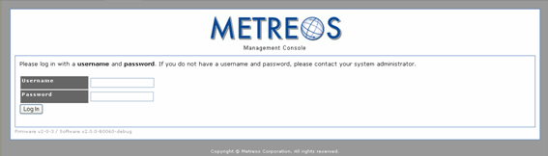
Figure 3: Management Console Login Screen

When you log in, the system presents the Main Control Panel:

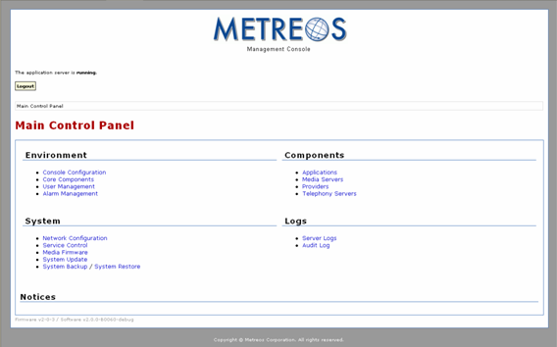
Figure 4: Metreos Management Console

The user interface is divided into four groups of related management activities:

- Environment
- System
- Components
- Logs

The Metreos Environment
The Environment group contains links to configuration pages for the Metreos operating environment. These include

- Console Configuration – An interface allowing you to set basic system attributes
- Core Components – An interface for configuring the core components described in System Overview
- User Management – A display of all users and a field for adding new users

Configuring the Console
The Console Configuration page enables you to manage basic settings for the console system and to restart the internal Web server as shown:

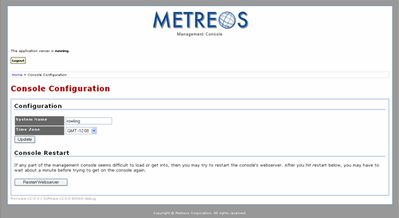
Figure 5: Console Configuration Display

You can change the System Name and Time Zone parameters. Press the Update button to effect the setting changes. You can also restart the Web server responsible for presenting the management console if necessary. Metreos recommends leaving the time set to GMT unless a specific need dictates a different Time Zone setting.

Configuring Core Components
The Core Components page allows you to configure the core components of the Application Runtime Environment:

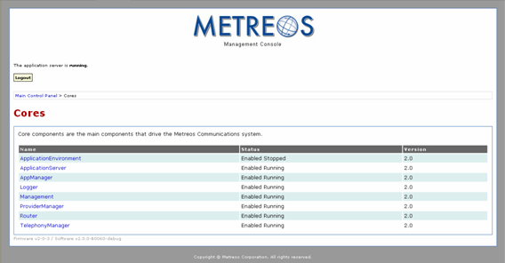
Figure 6: Core Components Management Interface

Clicking on any component link causes the system to display configurable parameters for that component.

Configuring the Application Environment

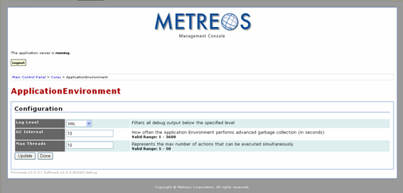
Figure 7: Application Environment Configuration Interface

Application environment parameters are

- Log Level – The type and amount of information you want the system to write to the log for each component. Refer to Table 1 in MCE Logs for supported levels.
- GC Interval – Garbage collection interval. Periodically, the system searches the runtime environment for objects no longer being used by the application but which have not released memory. It then removes those objects and any associated resources. The GC Interval field specifies the time interval in seconds between Garbage Collection events.
- Max Threads – The size of the thread pool used for concurrent execution of actions.

Configuring the Application Runtime Environment

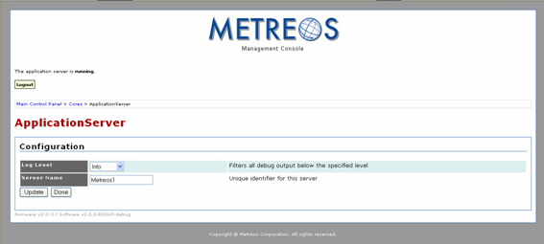
Figure 8: Application Runtime Environment Configuration Interface

Application Runtime Environment parameters are

- Log Level – The type and amount of information you want the system to write to the log for each component. Refer to Table 1 in MCE Logs for supported levels.
- Server Name – Identifier for the Application Runtime Environment.

Configuring the Application Manager

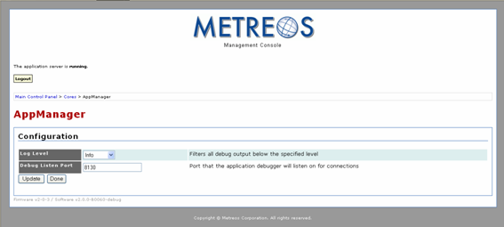
Figure 9: Application Manager Configuration Interface

Application Manager parameters are

- Log Level – The type and amount of information you want the system to write to the log for each component. Refer to Table 1 in MCE Logs for supported levels.
- Debug Listen Port – The port number on which the debugger is to listen for debug commands.

Configuring the Logger

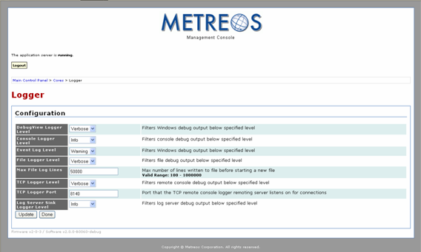
Figure 10: Logger Configuration Interface

Logger parameters are

- Log Level – The type and amount of information you want the system to write to the log for each component. Refer to Table 1 in MCE Logs for supported levels.
- Max File Log Lines – The maximum number of lines any log file can contain. When the log is full, a new log file is created with a timestamp as the file name.
- TCP Logger Port – The port number for the TCP connection of the Remote Console Logger

Configuring the Management Interface

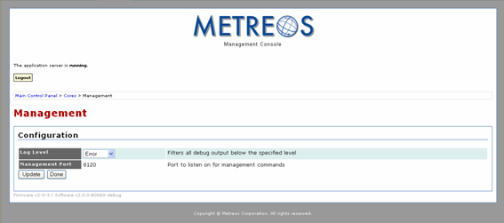
Figure 11: Management Interface Configuration Page

Use the Management Interface Configuration page to set the Log Level, which is t he type and amount of information you want the system to write to the log for each component. Refer to Table 1 in MCE Logs for supported levels.

Configuring the Provider Manager

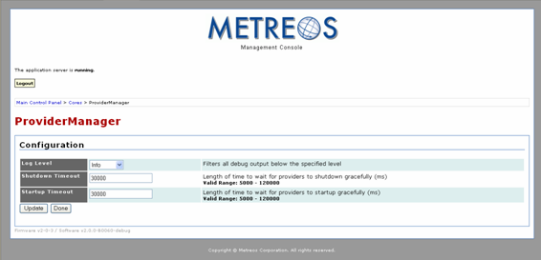
Figure 12: Provider Manager Configuration Interface

Provider Manager parameters are

- Log Level – The type and amount of information you want the system to write to the log for each component. Refer to Table 1 in MCE Logs for supported levels.
- Shutdown Timeout – The length of time in milliseconds the system will wait for a provider to shut down before forcibly unloading it.
- Startup Timeout – The length of time in milliseconds the system will wait for a provider to start before considering it unloadable.

Configuring the Router

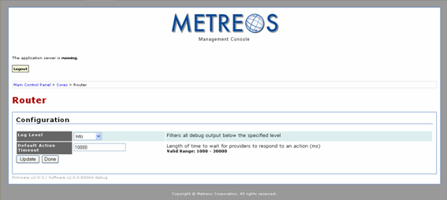
Figure 13: Router Configuration Interface

Router parameters are

- Log Level – The type and amount of information you want the system to write to the log for each component. Refer to Table 1 in MCE Logs for supported levels.
- Default Action Timeout – The maximum length of time in milliseconds the system will wait for a provider to respond to an Action.

Configuring the Telephony Manager

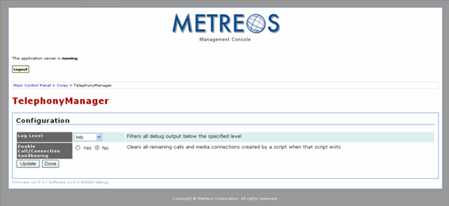
Figure 14: Telephony Manager Configuration Interface

Telephony Manager parameters are

- Log Level – The type and amount of information you want the system to write to the log for each component. Refer to Table 1 in MCE Logs for supported levels.
- Enable Call/Connection Sandboxing – When enabled, the system clears any remaining calls and media connections when the controlling script exits. Refer to Telephony Manager in Chapter 2 Metreos Application Runtime Environment Overview for information about sandboxing.

Managing Users

The User Management page lists all existing users, the access level of each user, and it presents an interface for adding users:

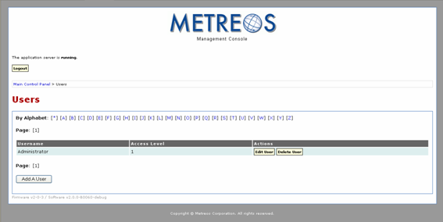
Figure 15: User Management Interface

To add a user

- Click the Add A User button located in the lower left corner:

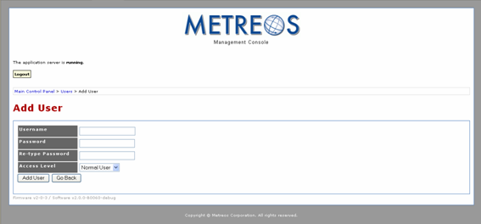
Figure 16: Add User Interface

- Enter a Username and an initial Password in their respective fields.
- Select either Normal User or Administrator from the Access Level pull down menu. Users who are assigned the Administrator role are allowed full access to the management console. Users who are assigned the Normal User role are allowed to manage only the following system components:

- Core Components
- Applications
- Media servers
- Providers
- Telephony Servers

- Click the Add User button to proceed:

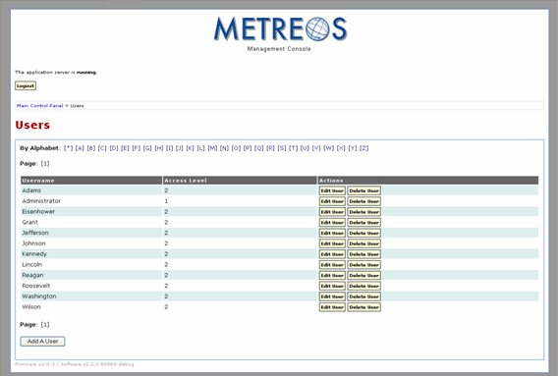
Figure 17: Updated User List – Default View

In addition to being able to view all users, you can also view only users whose names begin with a specified letter of the alphabet. To do so by click a letter in the alphabet string above the user list. Click the asterisk (*) next to the A in the alphabet string to return to the default view.

To edit a user click the Edit User button. To delete a user, click the Delete User button associated with the user. You can also edit a user’s username, password, and access level by clicking the Edit User button.

System Configuration and Control

The System group contains links to interfaces assisting you in managing system-level components. These include

- Network Configuration – View and editing your network configuration
- Service Control – Direct services on which Metreos relies
- Media Firmware – Activate a new media server license
- System Update – Uploading new system firmware and software
- System Backup / System Restore – Back up and restore Metreos 2400 system settings

Network Configuration
The Network configuration page displays the system’s current network configuration:

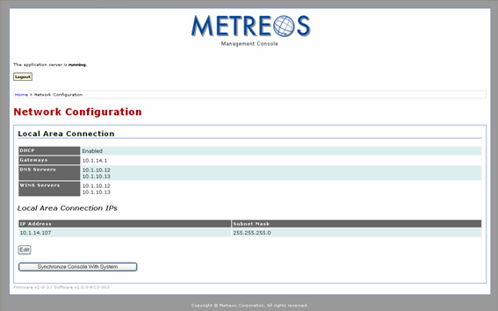
Figure 18: Network Configuration Page

If you know your network configuration has changed you can update the console settings by clicking the Synchronize Console With System button.

You can also statically configure your network configuration using the following procedure:

- Click the Edit button located near the lower right corner of the page:
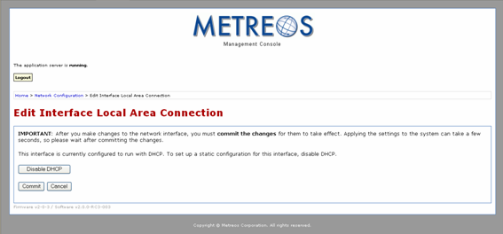
Figure 19: Network Configuration Page
- Click the Disable DHCP button:
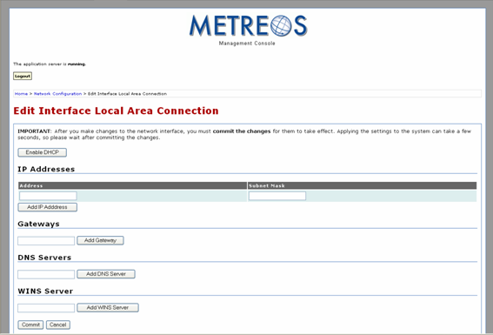
Figure 20: DHCP Configuration Page
- For each text field on the page, enter the configuration information and click the Add information button next to the field.
- Click the Commit button. The page will display the new configuration information.

Service Control
The service control interface page displays a table containing system-level services required by the runtime:

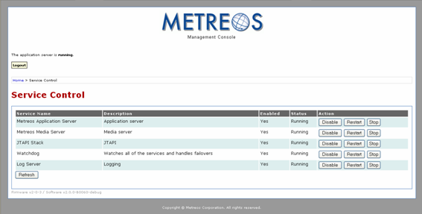
Figure 21: Service Control Interface

For each service, the table presents

- Service Name – Name of the service
- Description – A short description of the service
- Enabled – Yes or No
- Status:
  - Running – Service is available
  - Stop Pending – Service is shutting down
  - Stopped – Service is not available
  - Start Pending – Service is starting up
- Action:
  - Disable – Make service unavailable; disallow automatic start at reboot.
  - Restart – Stop and restart
  - Stop – Make service unavailable
  - Enable – Allow automatic start at reboot
  - Start – Make service available

An enabled service automatically starts when the system is rebooted; a disabled service does not. If you disable a service, the system will automatically stop the service. When you take some action on a service, click the Refresh button located at the bottom left of the page to update the current status display.

Media Firmware License
To upload a new firmware license

- Click the Media Firmware link on the Main Control Panel to view the Activate Media Firmware page:
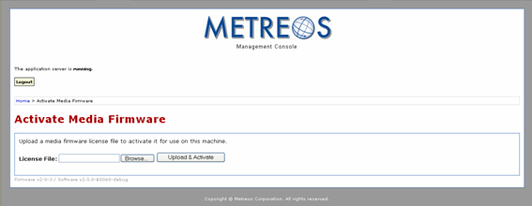 Figure 22: Activate Media Firmware Page
- Either type the local path of the license file in the License File field or click the Browse button to browse the hard drive.
- Click the Upload & Activate button.

System Update
You can update your application as follows:

- Click the System Update link on the Main Control Panel to view the Activate System Update page:

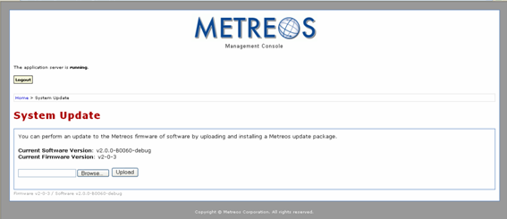
Figure 23: System Update Page

The page will display the firmware and software versions the system is currently using.

- Either type the local path of the update package file in the text field or click the Browse button to browse the hard drive.
- Click the Upload button. The update package will be validated, and release notes will be displayed:

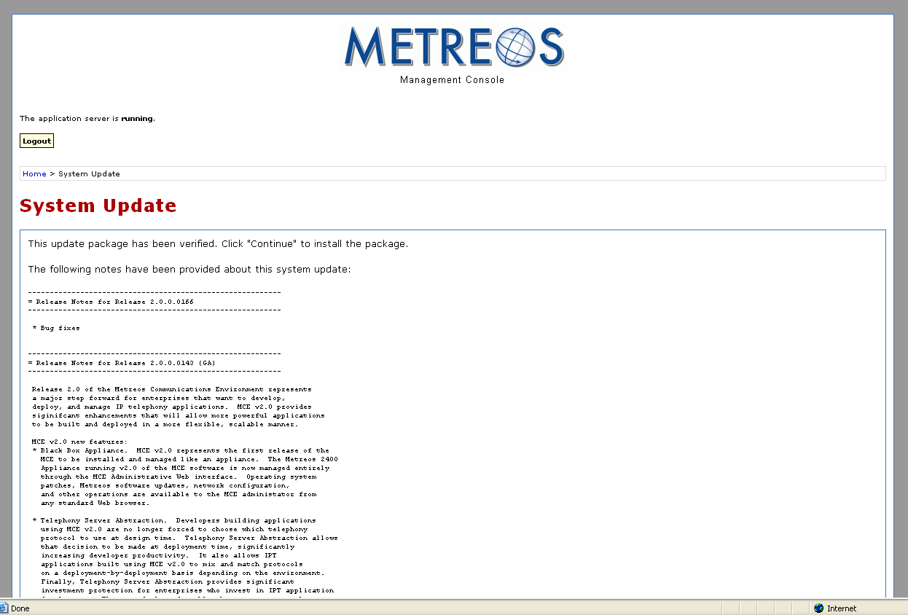
Figure 24: System Update release notes

- After reading the notes, click the Continue button at the bottom of the release notes to proceed. After the package is uncompressed, the system displays a self-refreshing In Progress… page:

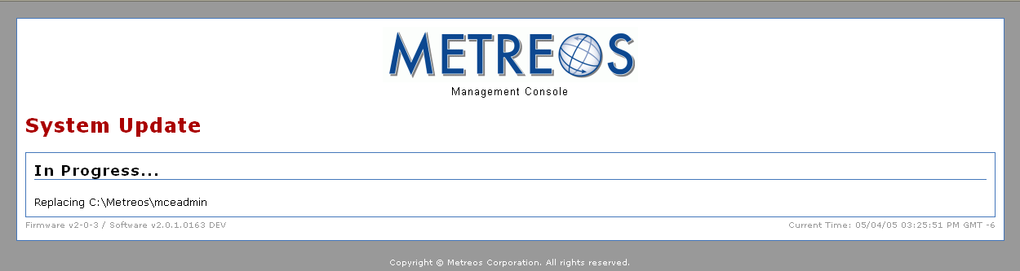
Figure 25: System Update In Progress
- When the update is complete, the system displays a page indicating whether the update succeeded:

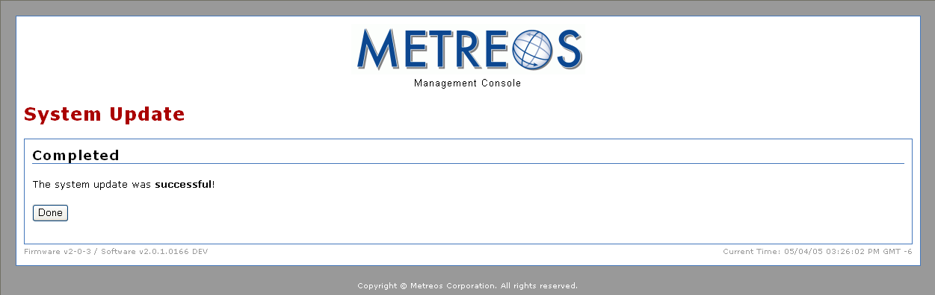
Figure 26: System Update Complete
- Click the Done button

System Backup and System Restore
We recommend you back up the system regularly to prevent data loss in the event of system failure. Use the following procedure to do so:

- Click the System Backup link to launch the System Backup page, which displays the application databases currently in use:
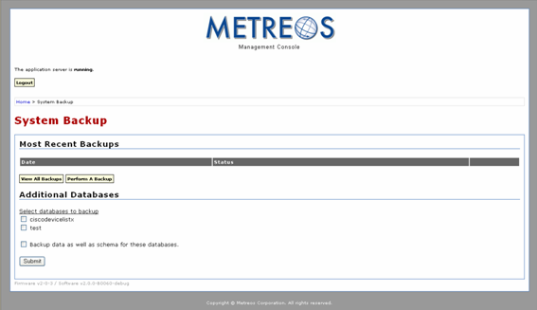
Figure 27: System Backup Page

- Configure the system backup by checking the application databases you want to back up:
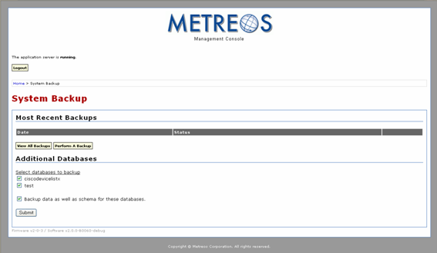
Figure 28: Selected Backup Configuration

NOTE: You can perform a system database backup without backing up application databases. Leave the application databases unchecked and skip to step four. The system database is always backed up when you perform the backup process.

- Click the Submit button to submit the backup configuration. The page will be updated to indicate the new backup configuration is now available:
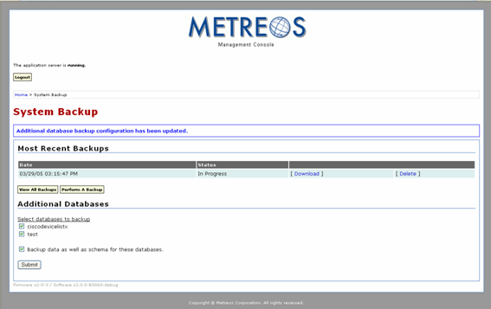
Figure 29: Backup Configuration Set

- Click the Perform A Backup button, which launches the Performing A Backup page:
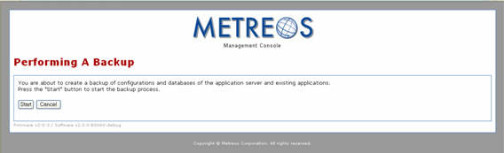
Figure 30: Start Backup

- Click the Start button to proceed. The system indicates the backup is in progress:

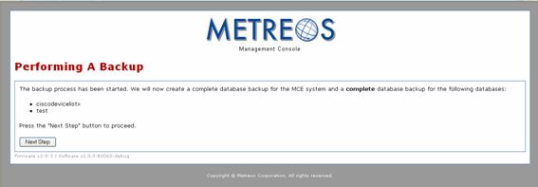
Figure 31: Backup in Progress

- Click the Next Step button to proceed. If the backup was successful the system notifies you with the following page:
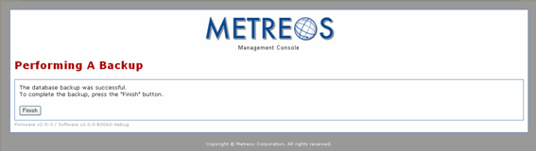
Figure 32: Finish Backup

- Click the Finish button to complete the process. The system indicates the backup is complete:

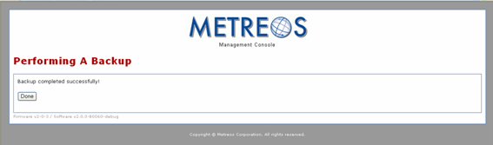
Figure 33: Complete Backup
- Clicking the Done button elicits a list of backup files, which you can then store
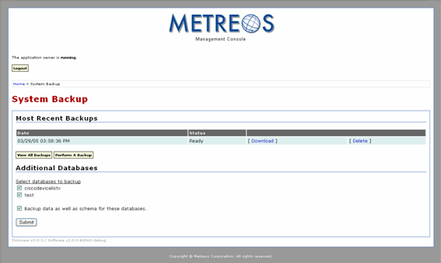
Figure 34: System Backup Page with Downloadable Backup File Complete

- You now have the option of either downloading or deleting the backup file. If you choose to download, click the Download button. The system will ask you to confirm you want to save the file as shown:
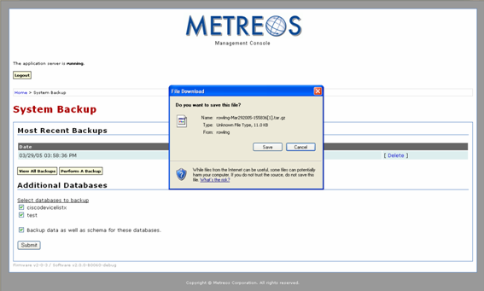
Figure 35: System Backup Save Feature
- Click Save to proceed. The system will display a Save As dialog:
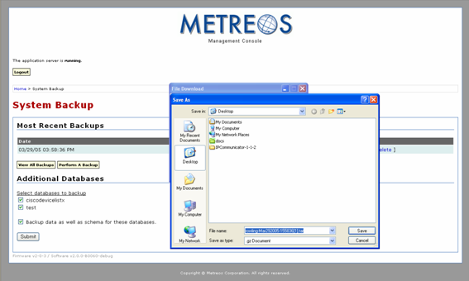
Figure 36: System Backup Save to Disc
- Choose the save destination for the file using the Save As dialog.
- To view a history of all backups click the View All Backups button:

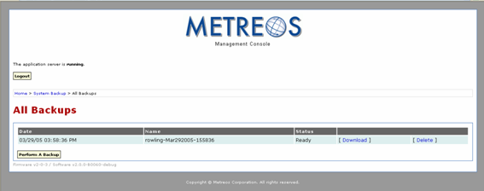
Figure 37: System Backup History
After you have backed up the system you can restore it if necessary. Use the following procedure:

- From the Main Control Panel, click the System Restore link:
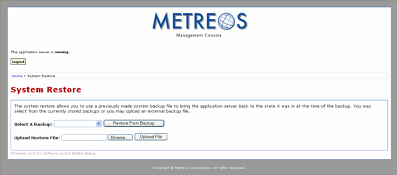
Figure 38: System Restore Page
- You have the option of selecting a backup file currently stored on the system or uploading it from a local drive. If you choose to use a system file, use the pull down menu from the Select A Backup field and then click the Restore from Backup button:
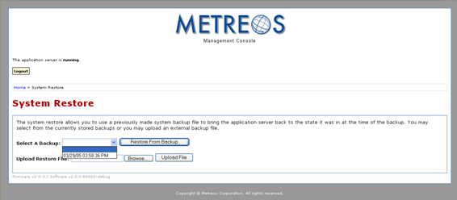
Figure 39: System Restore – File Selection
If you choose to restore from a file on a local drive, either type the full path in the Upload Restore File text field, or use the Browse button to locate the file and then click the Upload File button.

Working with Components
The management console provides access to the system components you will use to manage IP telephony applications. These include:

- Applications – Deploy and uninstall applications
- Media servers – Add and remove media servers
- Providers – An interface for adding and removing Providers
- Telephony Servers – An interface for adding and removing Telephony Servers

Managing Applications
The primary task you perform on the Applications interface page is installing and uninstalling applications. To install an application

- Click the Applications link on the Main Control Panel:
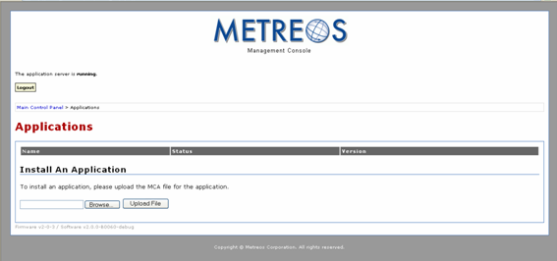
Figure 40: Application Manager Main Page
- Either type the full path of the install file or click the Browse button to locate it.
- Click the Upload File button. The Application Manager will first process the file and install the application, and then it will update the Applications page to list the application:

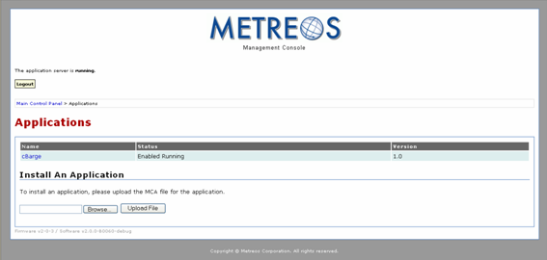
Figure 41: Application Manager with MCE Application
The page displays the application name (CBarge) the status (Enabled Running) and the version (1.0). The application name is displayed as a link. Clicking the link launches a page for managing the application:

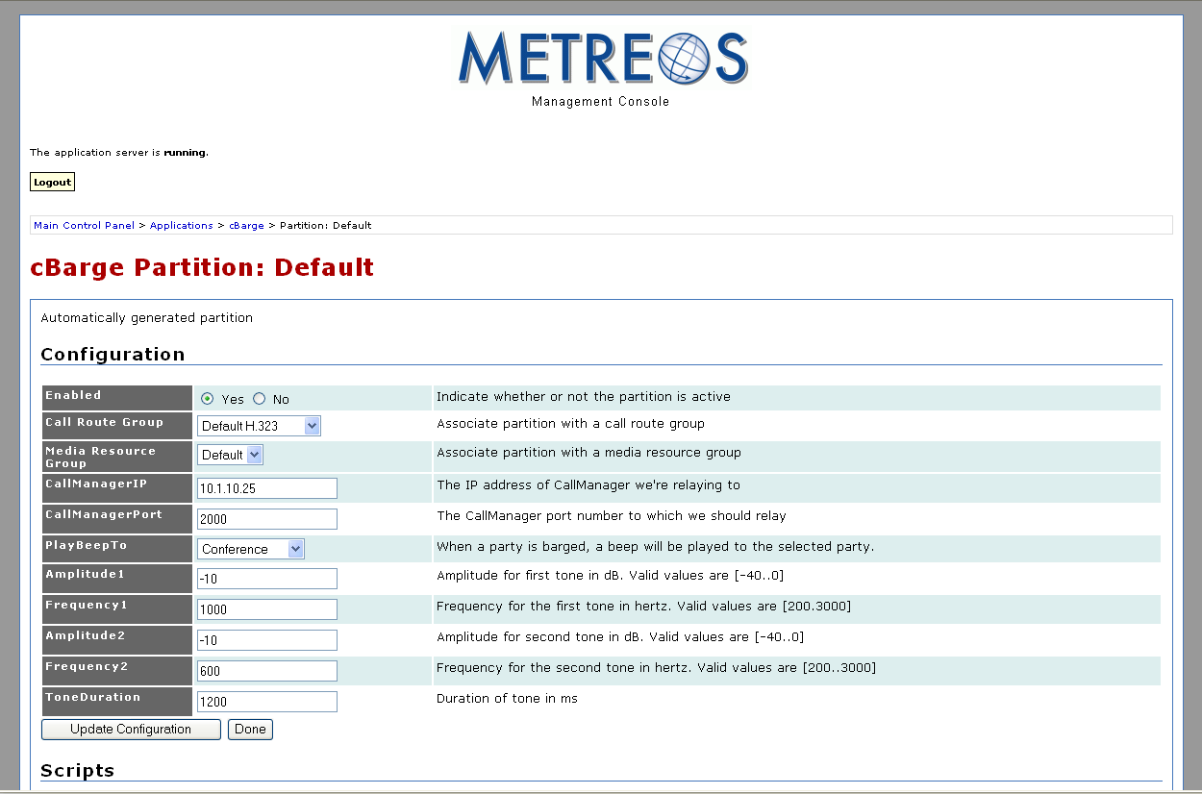
Figure 42: Application Manager with MCE Application

After the application is installed you can create additional partitions for it. Refer to Application Manager for an explanation of partitions. The parameters on all partitions are application specific. A default Metreos partition is assigned to the application. The following figure depicts a default partition:

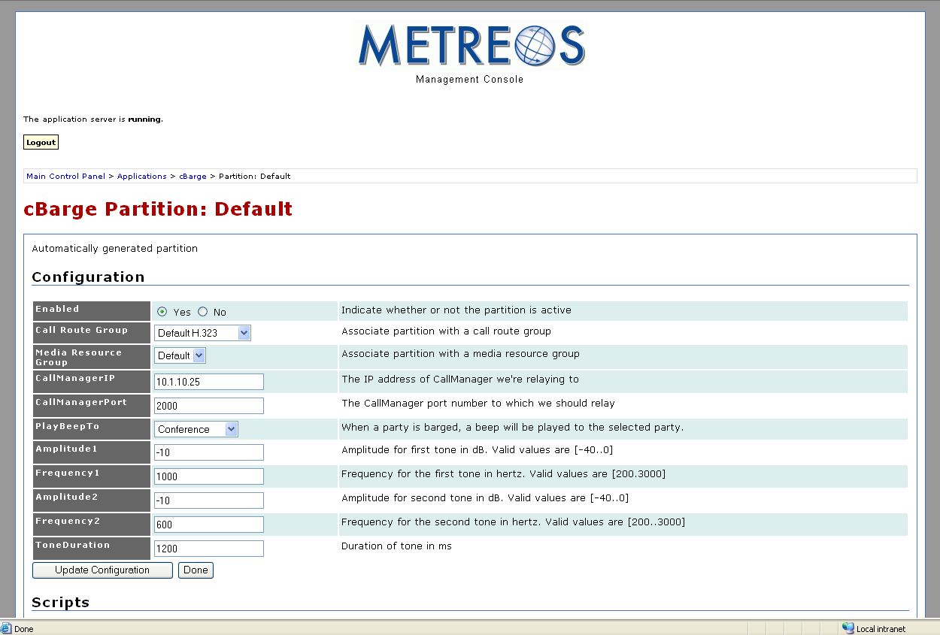
Figure 43: Default Partition

- Enable (Yes/No) – Activates or inactivates the partition
- Call Route Group (call_route_group_name) – Designates a call route group for the partition
- Media Resource Group (media_resource_group) – Designates a media resource group for the partition. Refer to Managing Media Servers for details.

- Click the Done button to return to the application page:

To create a new partition

- Click the Create Partition button, which launches the Create Partition page:

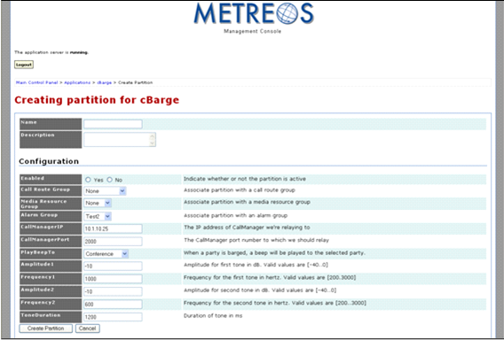
Figure 44: Application Partition Page
- Give the partition a name and enter it in the Name field located in the upper right corner of the page.
- Provide a description in the Description field located below the Name field.
- If you want to immediately enable the application partition click the Yes radio button next to Enabled; if not click the No radio button.
- Change any configuration parameters as needed for the partition you want to create.
- Click the Create Partition button to proceed:
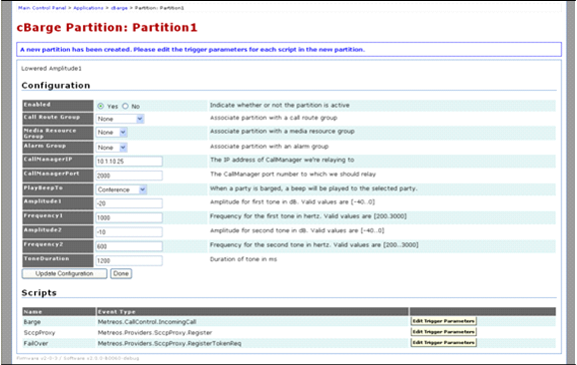
Figure 45: New Partition Added
WARNING: Parameter values are inherited from the default partition and all unchanged parameters in the new partition remain linked to parameters in the default partition. These parameter values will be updated in the new partition to match any changes made to them in the default partition.

Click the Done button to return to the application page:
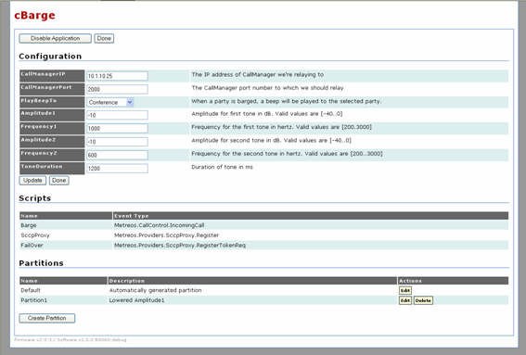
Figure 46: Example Partition Configuration
- For an enabled application, click the Disable Application button to disable the application.
- For a disabled application click the Enable Application button to enable the application.

To uninstall the application, first disable it then click the Uninstall Application button. The uninstall confirmation page will be displayed:

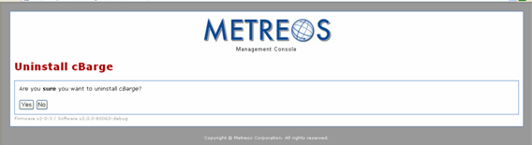
Figure 47: Application Manager Uninstall Page
Click the Yes button to proceed with the uninstallation, in which case the system will uninstall your application:

Managing Media Servers
The management console lets you create and configure media server groups and media servers. A media server group is a container for a collection of media servers, and each media server must be associated with one or more groups. Although you can create media server groups, it is not necessary to do so. The system provides a default media server group you can use if multiple groups are not needed. To add a media group

- Click the Media Servers link on the Main Control Panel:
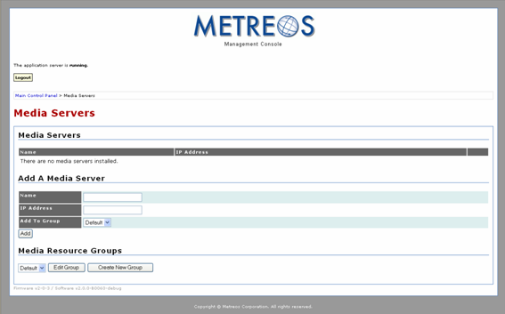
Figure 43: Media Servers Page
- Click on the Create New Group button located at the bottom of the Media Servers page:

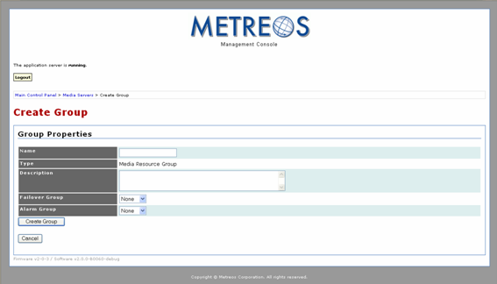
Figure 44: Media Servers Group Page
- Enter the group name in the Name text field.
- Enter a description of the group in the Description text field.
- If you would like to designate a failover group select the appropriate group from the Failover Group pull-down menu.
- Click the Create Group button to proceed. Clicking the Create Group button creates the group and presents the Edit Groups page:
- Click the Done button to return to the Media Servers page:
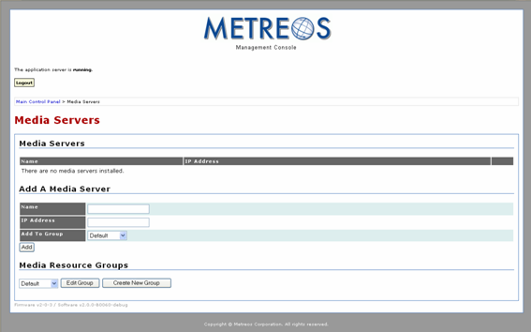
Figure 45: Add Media Server

You can now add a media server:
- Type the name of the media server in the Name text field.
- Type the IP address for the media server in the IP Address text field.
- Select the media server group for the media server from the Add To Group pull-down menu.
- Click the Add button to add the server. The system will add the server and display it in the Media Servers list:

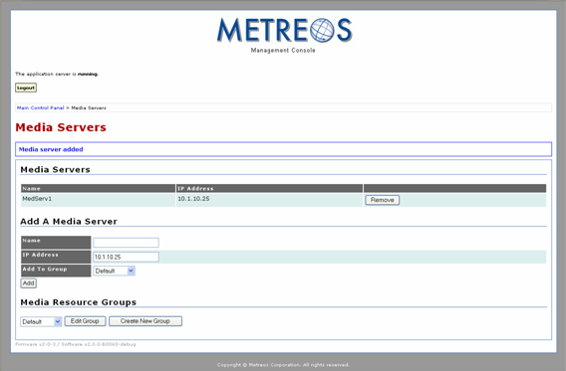
Figure 46: Media Server Added
You can confirm the Media Server was added to the correct group by selecting the group from the pull-down menu at the bottom of the page and clicking the Edit Group button:

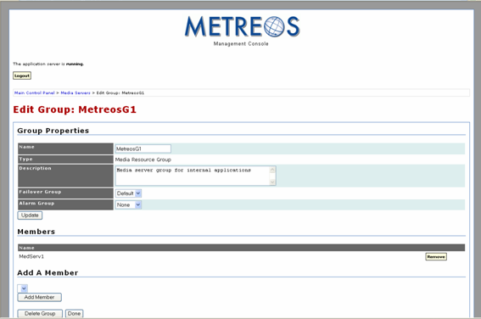
Figure 47: Media Server Displayed in Group
You can remove the media server from the group without removing it from the system by clicking the Remove button on this page located on the right hand side of the page:

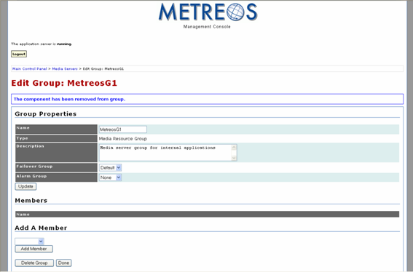
Figure 48: Media Server Deleted from Group
WARNING: A media server cannot be used unless it is associated with a group. If you remove a media server from a group you must reassign it to a group before an application can access it. It remains unusable by the Application Runtime Environment until you explicitly add it to a media server group.
To remove a media server from the system
- Go to the Media Servers page:
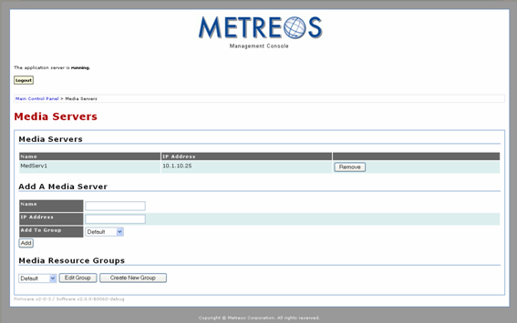
Figure 49: Remove Media Server
- Click the Remove button:
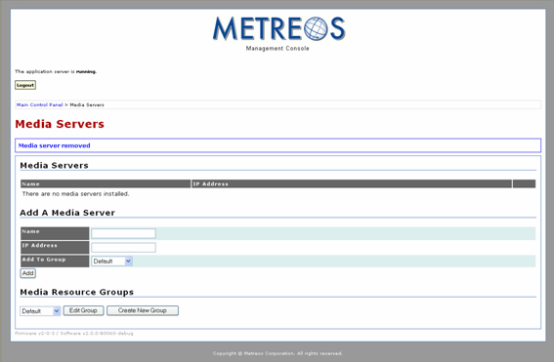
Figure 50: Media Server Removed from System

Managing Providers
Using the management console, you can configure, disable, and uninstall providers. Clicking on the Providers link in the Components group of the Main Control Panel launches the Providers page:

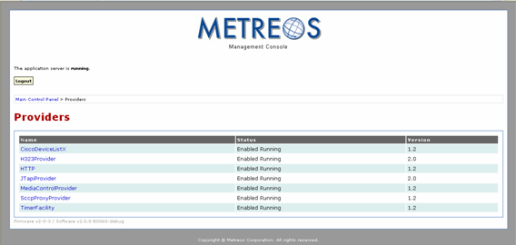
Figure 51: Provider Management Page
The page displays the list of providers shipping with the Metreos 2400 system, the status of each (Enabled Running or Disabled), and the version number. Clicking on the provider name launches the configuration page for that provider, and from there you can disable the provider or edit the configuration.

Provider Configuration Pages
The following screen shot depicts a sample provider configuration page:

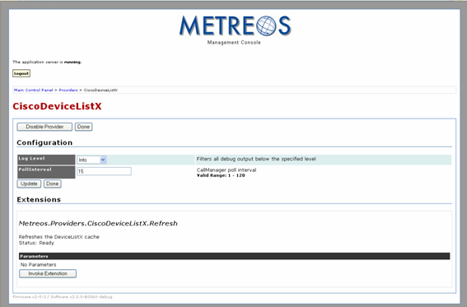
Figure 52: Sample Provider Configuration Page
The configuration page for a provider is divided into three sections:

- Enable/Disable Provider – Enable and disable switch
NOTE: Disabling the provider allows you to subsequently uninstall the provider. Uninstalling a provider resets it back to its default configuration settings and makes it unavailable. To restart the provider, restart the Application Runtime Environment; the provider will be restarted automatically.
- Configuration – Configurable parameters for the provider
- Extensions – Special actions exposed by the provider that are invoked only through the Management Console rather than by a script. Not all providers have extensions. To invoke the extension click the Invoke Extension button.

Configuring CiscoDeviceListX
Refer to figure x previously presented. The CiscoDeviceListX parameters are

- Log Level – The type and amount of information you want the system to write to the log for each component. Refer to Table 1 in MCE Logs for supported levels.
- PollInterval – The interval between requests sent to CallManagers to refresh device information (cache refresh).

Configuring H323
To configure H323, click the H323 link on the Providers page:

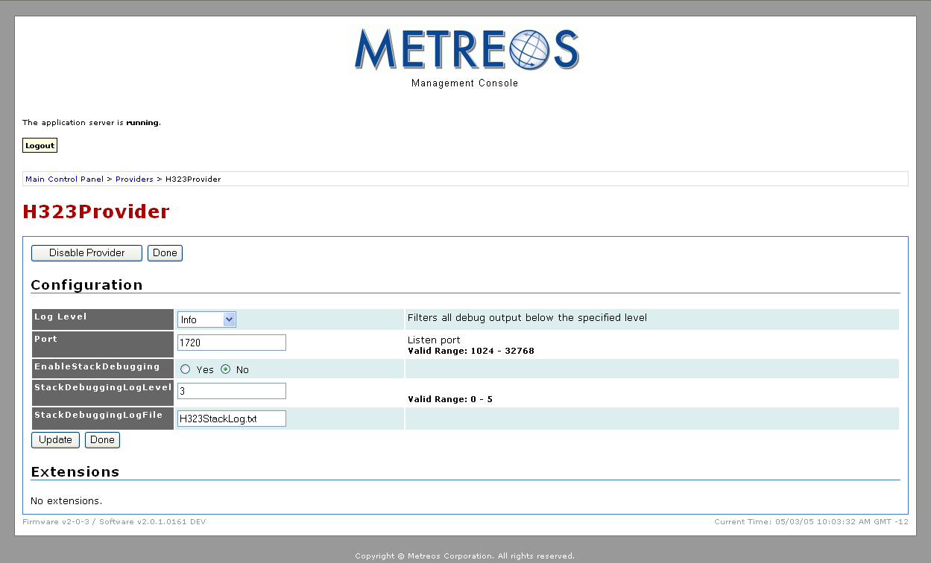
Figure 53: H323 Provider Configuration Page

The H323 provider parameters are
- Log Level – The type and amount of information you want the system to write to the log for each component. Refer to Table 1 in MCE Logs for supported levels.
- Port – The number of the port on which H323 listens
- EnableStackDebugging – Enables the StackDebugger, a tool that writes logs to a file for H.323 diagnostics
- StackDebuggingLogLevel – Log level specifying the detail of logs written by the StackDebugger. Valid values are 0 – 5; 0 is no debugging, and 5 is maximum debugging.
- StackDebuggingLogFile – The name of the log file for the StackDebuggingLog function
- EnableProcessWindow – Configures H323 to write debug output to a window rather than a log file. Deprecated

To effect configuration changes click the Update button. Click Done to return to the providers page.

Configuring the HTTP Provider
To configure HTTP, click the HTTP link on the Providers page:

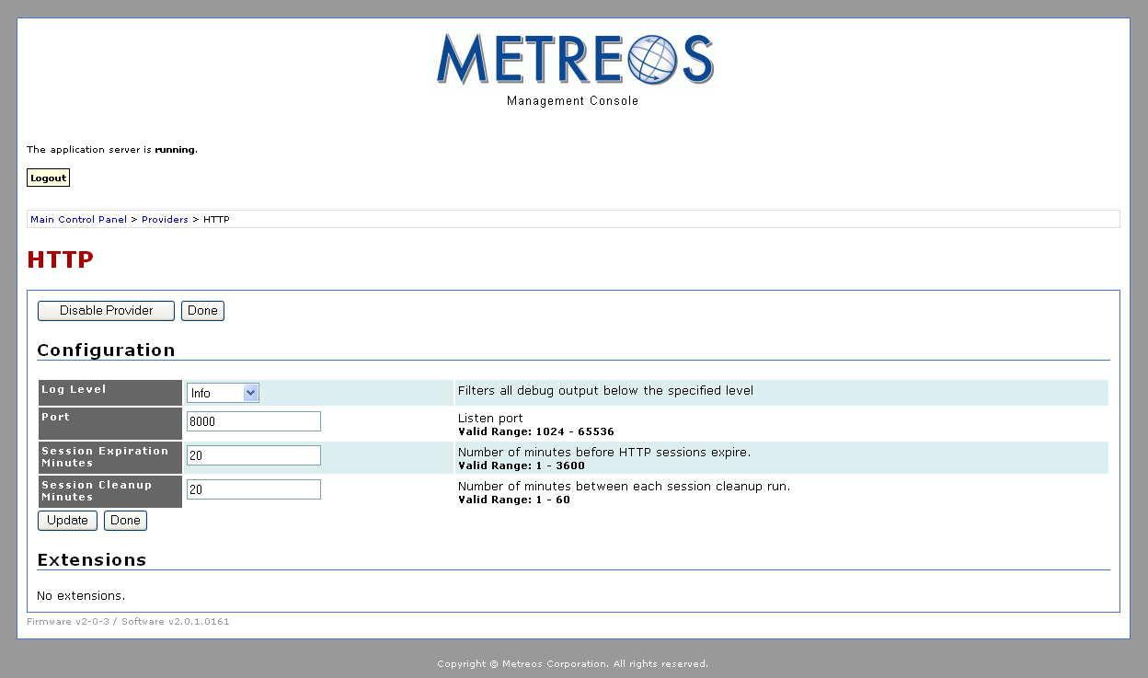
Figure 54: HTTP Provider Configuration Page
The HTTP provider parameters are

- Log Level – The type and amount of information you want the system to write to the log for each component. Refer to Table 1 in MCE Logs for supported levels.
- Name – The name of the HTTP provider
- Port – The number of the port on which the provider listens
- Session Expiration Minutes – The number of inactive minutes before the session is automatically terminated.
- Session Cleanup Minutes – The interval between clean-up of resources for terminated sessions in minutes.

To effect configuration changes click the Update button. Click Done to return to the providers page.

Configuring JTapiProvider
JTAPI uses CTI ports and Route points specified in Creating CTI Telephony Devices are for first party calls. The devices configured in this section, however, are exclusively for monitoring third party calls.

To configure the JTAPI Provider, click the JTapiProvider link on the Providers page:

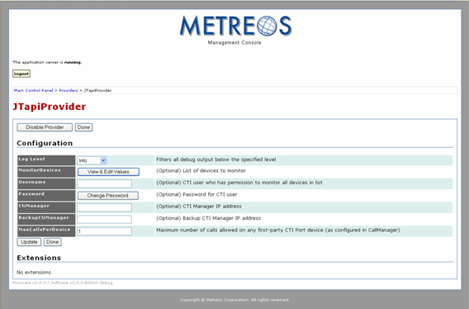
Figure 55: JTapi Provider Configuration Page

The JTAPI provider parameters are

- Log Level – The type and amount of information you want the system to write to the log for each component. Refer to Table 1 in MCE Logs for supported levels.
- MonitorDevices – Devices to monitor. Clicking the View & Edit Values button launches the Monitor Devices page:
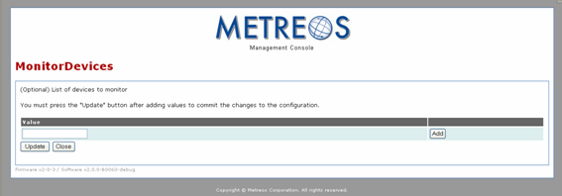
Figure 56: JTapi Provider Configuration Page
The value you specify in Values text field is the exact device name registered in CallManager for the devices you want to monitor.
- Username – Username having permission to monitor the specified devices
- Password – Account password for user having permission to monitor the specified devices. Clicking the Change Password button launches the Change Password page:
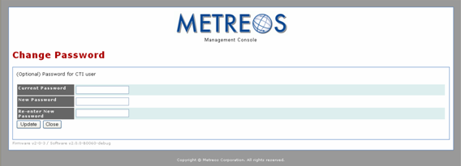
Figure 57: JTapi Provider Change Password Page
To change the password
  - Enter the current password in the Current Password text field
  - Enter the new password in the New Password text field
  - Re-enter the new password in the Re-enter New Password text field
- CtiManager – The IP address for CTI Manager
- BackupCtiManager – The backup IP address for CTI Manager
- MaxCallsPerDevice – The maximum number of calls allowed on any first-party CTI Port device. This value must match the equivalent value in Cisco CallManager.
NOTE: Route Points are not affected by this value.

To effect configuration changes click the Update button. Click the Done button to return to the Providers page.

Configuring MediaControlProvider
MediaControlProvider parameters are

- Log Level – The type and amount of information you want the system to write to the log for each component. Refer to Table 1 in MCE Logs for supported levels.
- Connect Timeout – The amount of time in milliseconds before a connection is deemed unsuccessful and attempts to retry the connection.
- Disconnect Timeout – The amount of inactive time in milliseconds before terminating the connection.
- Heartbeat Interval – The interval in seconds between heartbeat signals to a media server.
- Heartbeat Skew – The amount of time in seconds MediaControlProvider waits for a response to the heartbeat signal.
- DiagInboundConnectMessages – Writes inbound connect messages to the Log Server
- DiagOutboundConnectMessages – Writes outbound connect messages to the Log Server
- DiagOutboundDisconnectMessages – Writes outbound disconnect messages to the Log Server
- DiagOutboundCommandMessages – Writes outbound command messages to the Log Server
- DiagInboundResponseMessages – Writes responses to the Log Server
- DiagHeartbeatResourceInfo – Writes heartbeat signal information to the Log Server

Configuring Telephony Servers
The management console enables you to create and edit call route groups and telephony servers. Like media server groups, a call route group is a container for a collection of telephony servers, and each server must belong to one or more groups.

Creating groups is optional because the system provides default call route groups you can use if multiple groups are not needed. Click the Telephony Servers link on the Main Control Panel:
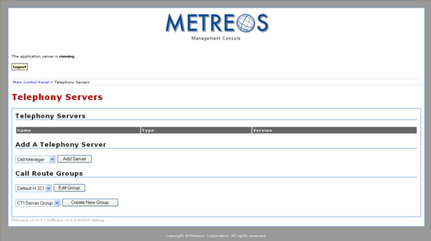
Figure 58: Telephony Servers Page
The Application Runtime Environment currently supports two Call Control protocols:

- H.323
- CTI

It also supports two types of telephony servers:

- H.323 gateways – Telephony servers, which are used exclusively with H.323
- Call Managers – Multipurpose telephony server devices supporting SCCP and CTI in the Metreos system

Creating H.323 Call Route Groups and Gateways
The following procedures describe how to set up H.323 call routing groups and gateways. To create a H.323 call route group

- Select H.323 from the Create New Group pull-down menu:
- Click the Create New Group button:
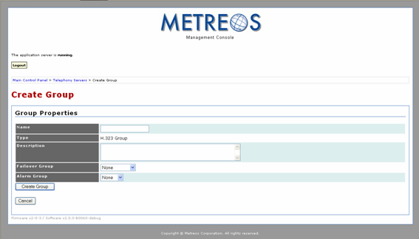
Figure 59: Configuring a New H323 Telephony Group
- Enter the name of the group in the Name text field.
- Enter a description in the Description text field.
- Select the appropriate failover group from the Failover Group pull-down menu.
- Select Create Group to proceed:
- Click the Telephony Servers link in the upper left portion of the page to return to the Telephony Servers page:
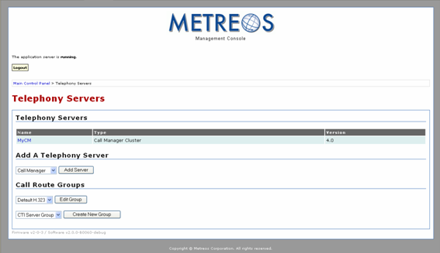
Figure 60: Added H323 Telephony Group
You can now create a H.323 gateway:

- Select H.323 Gateway from the Add Server pull down menu.
- Click the Add Server button:
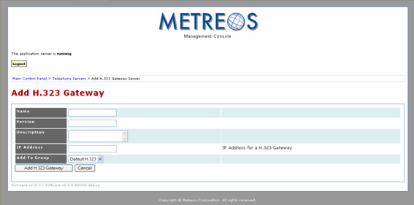
Figure 61: Configuring H323 Telephony Server
- Enter the server name in the Name text field.
- Type the CallManager version in the Version text field
NOTE: The Metreos 2400 supports 3.3, 4.0, and 4.1. Enter only the first two digits of the version number (4.0 not 4.0.1). If the gateway is not part of a CallManager installation, enter 1.0.
- Enter the IP address in the IP Address text field.
- Select the appropriate group from the Add To Group pull-down menu.
- Click the Add H.323 Gateway to create the server:
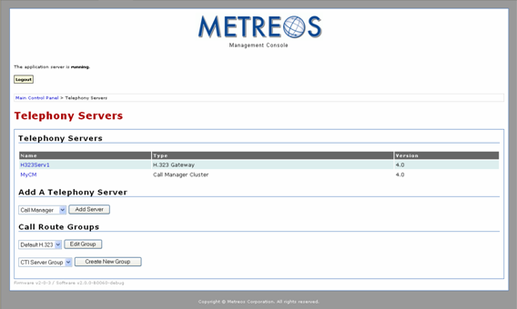
Figure 62: H323 Telephony Server Added

Creating CTI Telephony Devices
Computer Telephony Integration (CTI), unlike H.323, is an IP telephony protocol based on the notion of line-oriented telephony devices. This section describes how to set up and administer CTI ports and Route Points which are configured on a CTI Manager.

A CTI Route Point is a group unto itself. CTI ports are grouped into Device Pools. Both CTI ports and Route Points must have at least one CTI manager associated with them. CTI groups should contain exactly one Route Point or one Device Pool. Further, the Application Runtime Environment will not allow a CTI group containing a combination of Route Points and Device Pools.

CTI Route Points and Device Pools are contained within a CTI Manager and are associated with CTI Groups. The following procedures describe how to create

- CTI Groups
- CTI Managers
  - CTI Route Points
  - CTI Device Pools

To create a CTI route group

- Ensure CTI Server Group is selected on the CTI Server Group pull-down menu and click the Create New Group button:

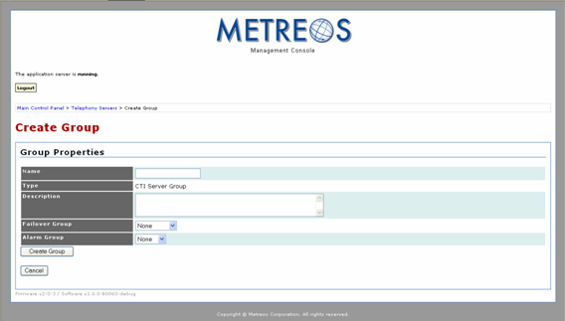
Figure 62: Configuring a New CTI Telephony Group
- Enter the name of the group in the Name text field.
- Enter a description in the Description text field.
- Select the appropriate failover group from the Failover Group pull-down menu.
- Click the Create Group button to proceed:

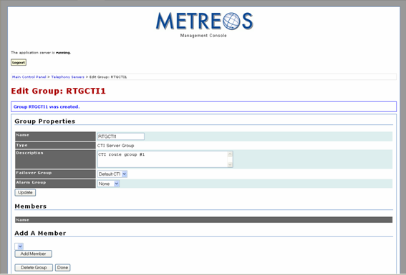
Figure 63: New CTI Telephony Group Created
- Click the Done button:

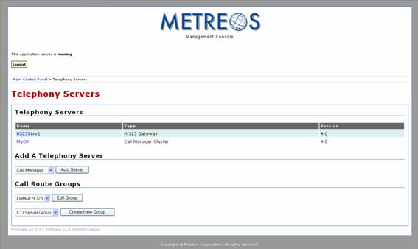
Figure 64: New CTI Telephony Group Added

The MCE relies on the Call Manager CTI cluster implementation, and the page therefore contains references to Call Manager. All Metreos CTI clusters are referred to as Call Manager clusters. You can create a CallManager cluster associated with the new group:

- Ensure Call Manager is displayed in the Add Server pull-down menu and click the Add Server button:

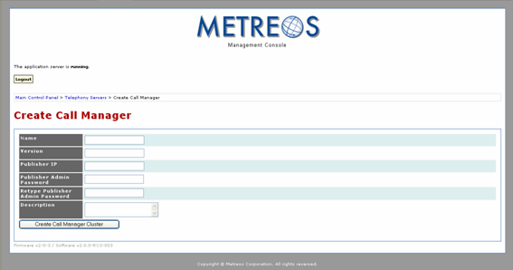
Figure 65: Configuring a New CallManager
- Enter the server name in the Name text field.
- Enter the major and minor versions of the CallManager (e.g. 4.0) in the Version text field.
- Enter the IP address in the Publisher IP Address text field.
- Enter the password for the Publisher Administrator.
- Click the Create Call Manager Cluster button to Proceed:

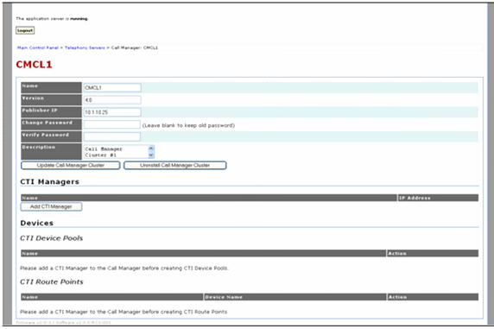
Figure 66: New CallManager Created
You can now create CTI devices. To create a CTI manager

- Click the Add CTI Manager button:

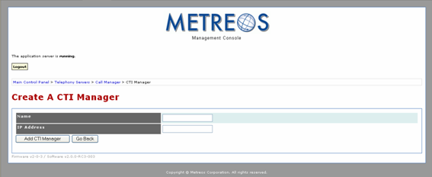
Figure 67: Configuring a New CTI Manager
- Enter the manager name in the Name text field.
- Enter the IP address in the IP Address text field.
- Click the Add CTI Manager to proceed:
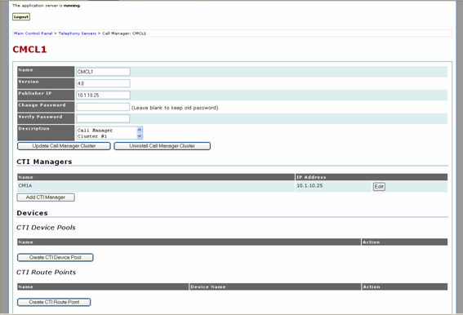
Figure 68: New CTI Manager Added
You can now create devices the manager will contain. To create a Device Pool

- Click the Create CTI Device Pool button:

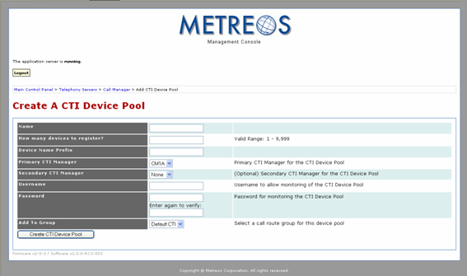
Figure 69: Configuring a New CTI Device Pool
- Enter the name of the pool in the Name field.
- Enter the number of devices in the pool in the How Many Devices to Register? field.
- For every device created within the Device Pool, the runtime will assign a name constructed by concatenating a prefix you designate with a sequentially assigned number. For example, designating a prefix of MyDevice results in a name of MyDevice1 for the first device and MyDevice2 to the second device. Enter a designated prefix for the devices in your pool in the Device Name Prefix field.
- Select the CTI manager you previously created from the Primary CTI Manager pull-down menu.
- If you want a secondary CTI manager to be available for the Device Pool, create one and select it from the Secondary CTI Manager pull-down menu.
- Enter the name of a user with permission to control this Route Point in the Username text field.
- In the Password text field, enter the password for the user account in the Username field.
- Select the group you created from the Add To Group pull-down menu.
- Click the Create CTI Device Pool to proceed:
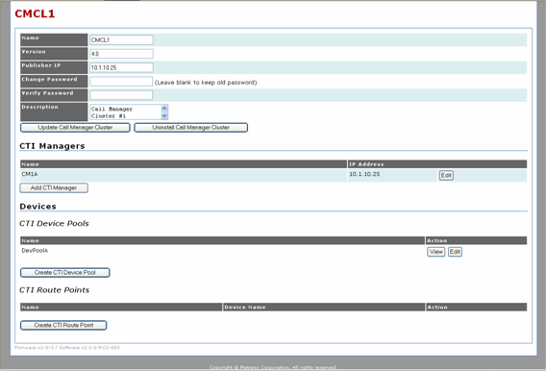
Figure 70: New CTI Device Pool Created

You can also create a Route Point:

- Click the Create CTI Route Point button:
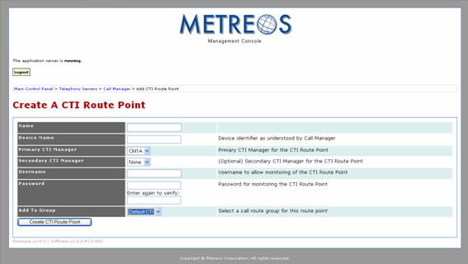
Figure 71: Configuring a New CTI Route Point
- Enter the Name of the Route Point enter the name of the Route Point.
- The Cisco Call manager must know about this device. Enter the device name from Cisco CallManager in the Device Name field.
- Ensure sure the CTI Manager you previously created is selected from the Primary CTI Manager pull-down menu.
- If you want to have a secondary CTI manager, create it and select it from the Secondary CTI Manager pull-down menu.
- Enter the username for the individual responsible for monitoring the Route Point in the Username text field.
- In the Password text field, enter the password for the user account in the Username field.
- Select the group you created from the Add To Group pull-down menu.
- Click the Create CTI Route Point button to proceed:
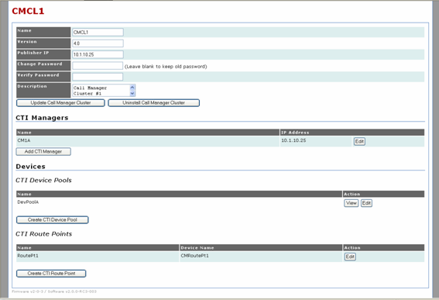
Figure 72: New CTI Route Point Created
You can view and edit any of these devices by clicking any of the View and Edit buttons associated with them.

Metreos Logs
The MCE provides three logs containing diagnostic information:

- Server Logs – Containing information about server activity
- Event Log – Containing information about system events (e.g. H.323 stack is unavailable)
- Audit Log – All MCE activity

The MCE supports the concept of log level filtering. The log level determines the amount of recorded detail about logged events. The following table presents the supported Log Levels:

Log Level | Description
Off | No logging
Error | Writes only error messages to log
Warning | Writes only warning and error messages to log
Info | Writes warning, error, and terse information messages about events to the log
Verbose | Writes warning, error, and detailed information messages about events to the log
Table 2: Log Level Settings

Index

A
Administrator, 17
Application Environment, 7
Application Manager, 6, 8
Application Runtime Environment, 8
Application Runtime Environment, 5, 6
C
CallManager cluster, creating, 54
Console Configuration, 11
Console Logger, 9
core components, 6, 11
CTI clusters, 54
CTI devices, creating, 55
CTI route group, creating, 52
CTI Route Point, Creating, 58
D
Debug Logger, 9
Device Pool, creating, 56
disabled service, 21
E
enabled service, 21
Environment group, 11
Event Logger, 9
F
File Logger, 9
H
H.323 call route group, creating, 49
H.323 gateway, creating, 50
L
log level, 12
Log Server Logger, 9
Logger, 7
M
Management Interface, 7, 8
media group, adding, 37
media server, adding, 38
media server, removing, 41
Metreos Communications Environment, 5
Metreos Management Console, 10
Metreos Visual Designer, 5
N
new partition, creating, 34
Normal User, 17
P
partition, 8, 33, 34, 35
Provider Manager, 6, 7
R
Remote Console Logger, 9
Router, 6, 7
S
sandboxing, 7, 16
T
Telephony Manager, 6, 7
thread pool, size of, 13
U
User Management, 11

